ACCIDENT REPORT FORM 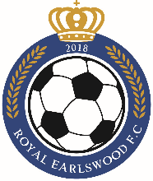
Royal Earlswood Football Club
This form should be completed by the youth worker on the scene at the time of any accident, and as soon after the event as possible. The report should then be handed to David Coogan to complete the subsequent action taken section.

Date, time and location of accident:

Name and role of person completing form:

Name of injured person:

Address of injured person:
Nature of incident/injury and extent of injury:
Give details of how and precisely where the incident took place:
Describe what activity was taking place e.g. football, chopping food.

Give full details of action taken during any first aid treatment and the
name(s) of first-aider(s):

Were any of the following contacted or notified?
Parents/carers Yes No Details:
Police Yes No Details:
Ambulance Yes No Details:
Other

Who was the accident reported to in the group?
e.g. Health & Safety Officer, Group Leader. Please include date and method.

What happened to the injured person following the incident/accident?
e.g. Health & Safety Officer, Group Leader. Please include date and method.

All of the above facts are a true record of the accident/incident
Signed:
Date:
Name:

Subsequent action taken:

No action taken:
Please provide reasons

Signed:
Date:
Name:

